**SQLite Database**

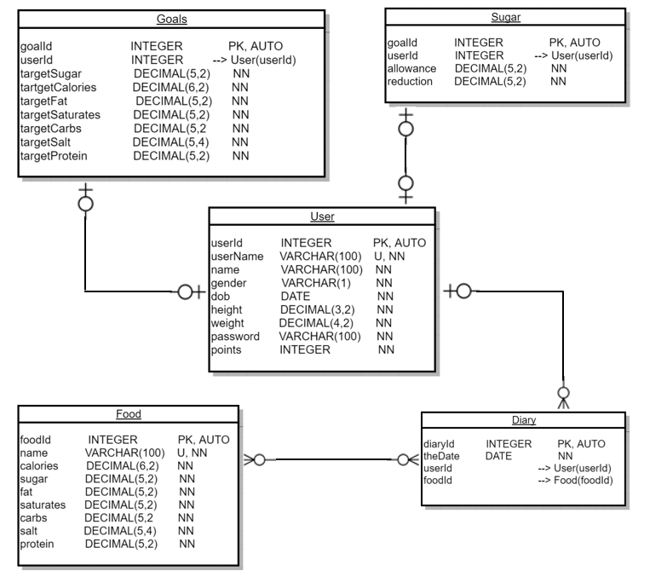

**DROP TABLE** IF **EXISTS** Sugar;   
**DROP TABLE** IF **EXISTS** Goals;   
**DROP TABLE** IF **EXISTS** Diary;   
**DROP TABLE** IF **EXISTS** Food;   
**DROP TABLE** IF **EXISTS User**;   
  
**CREATE TABLE User** (  
 userId **INTEGER NOT NULL PRIMARY KEY** AUTOINCREMENT,   
 userName **VARCHAR**(100) **NOT NULL**,   
 name **VARCHAR**(100) **NOT NULL**,   
 gender **VARCHAR**(1) **NOT NULL**,   
 dob **DATE NOT NULL**,   
 height **DECIMAL**(3, 2) **NOT NULL**,   
 weight **DECIMAL**(4, 2) **NOT NULL**,  
 password **VARCHAR**(100) **NOT NULL**,   
 points **INTEGER NOT NULL**,   
 **CONSTRAINT** userName_unique **UNIQUE** (userName)  
);  
  
**CREATE TABLE** Food (  
 foodId **INTEGER NOT NULL PRIMARY KEY** AUTOINCREMENT,   
 name **VARCHAR**(100) **NOT NULL**,  
 calories **DECIMAL**(5,2),   
 sugar **DECIMAL**(5, 2),  
 fat **DECIMAL**(5, 2),   
 saturates **DECIMAL**(5, 2),   
 carbs **DECIMAL**(5, 2),   
 salt **DECIMAL**(5, 4),   
 protein **DECIMAL**(5, 2),  
 **CONSTRAINT** name_unique **UNIQUE** (name)  
);  
  
**CREATE TABLE** Diary (  
 diaryId **INTEGER NOT NULL PRIMARY KEY** AUTOINCREMENT,   
 theDate **DATE NOT NULL**,   
 userId **INTEGER NOT NULL**,   
 foodId **INTEGER NOT NULL**,   
 **CONSTRAINT** fk_userId **FOREIGN KEY** (userId) **REFERENCES User**(userId),   
 **CONSTRAINT** fk_foodId **FOREIGN KEY** (foodId) **REFERENCES** Food(foodId)  
);   
  
**CREATE TABLE** Goals (  
 goalId **INTEGER NOT NULL PRIMARY KEY** AUTOINCREMENT,   
 userId **INTEGER NOT NULL**,  
 targetSugar **DECIMAL** (5, 2),   
 targetCalories **DECIMAL**(5, 2),   
 targetFat **DECIMAL**(5, 2),   
 targetSaturates **DECIMAL**(5, 2),   
 targetCarbs **DECIMAL**(5, 2),   
 targetSalt **DECIMAL**(5, 2),   
 targetProtein **DECIMAL**(5, 2),  
 **CONSTRAINT** unique_userId **UNIQUE** (userId),  
 **CONSTRAINT** fk_userId **FOREIGN KEY** (userId) **REFERENCES User**(userId)  
);  
  
  
**CREATE TABLE** Sugar (  
 goalId **INTEGER NOT NULL PRIMARY KEY** AUTOINCREMENT,   
 userId **INTEGER NOT NULL**,  
 allowance **DECIMAL**(5, 2),   
 reduction **DECIMAL**(5, 2),  
 **CONSTRAINT** unique_userId **UNIQUE** (userId),  
 **CONSTRAINT** fk_userId **FOREIGN KEY** (userId) **REFERENCES User**(userId)  
);

**Online MySQL Database**

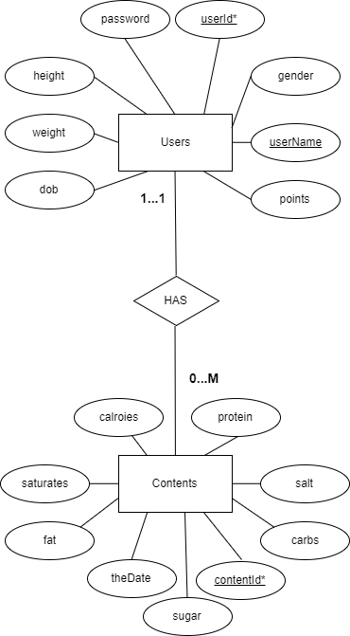

**DROP TABLE** IF **EXISTS** Contents;   
**DROP TABLE** IF **EXISTS** Users;   
  
**CREATE TABLE** Users (  
 userId **INTEGER NOT NULL PRIMARY KEY** AUTO_INCREMENT,   
 userName **VARCHAR**(100) **NOT NULL**,   
 name **VARCHAR**(100) **NOT NULL**,   
 gender **VARCHAR**(1) **NOT NULL**,   
 dob **DATE NOT NULL**,   
 height **DECIMAL**(3, 2) **NOT NULL**,   
 weight **DECIMAL**(4, 2) **NOT NULL**,  
 password **VARCHAR**(100) **NOT NULL**,   
 points **INTEGER NOT NULL**,   
 **CONSTRAINT** userName_unique **UNIQUE** (userName)  
);  
  
**CREATE TABLE** Contents(  
 contentId **INTEGER NOT NULL PRIMARY KEY** AUTO_INCREMENT,   
 userId **INTEGER NOT NULL**,   
 theDate **DATE NOT NULL**,   
 calories **DECIMAL**(6,2),   
 sugar **DECIMAL**(5, 2),  
 fat **DECIMAL**(5, 2),   
 saturates **DECIMAL**(5, 2),   
 carbs **DECIMAL**(5, 2),   
 salt **DECIMAL**(5, 4),   
 protein **DECIMAL**(5, 2)  
);